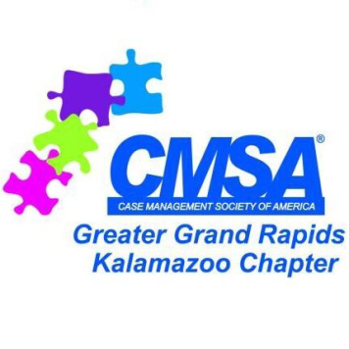
Case Management Society of America
Greater Grand Rapids/Kalamazoo Chapter
Scholarship Application 2015/2016

Name: _______________________________________________________________________
Address: ______________________________________________________________________
Phone: _______________________________________________________________________
Email: ________________________________________________________________________
College/University Attending: ____________________________________________________
Major (Nursing/Social work): ___________________________________ Junior Senior
GPA: _________________________________________________________________________

Criteria
- Student in good standing
- Minimum GPA of 3.25
- Nursing or Social Work student
- Junior or Senior level

Essay
Pick one to answer, 500 word maximum
- Where do you see the field of case management in the next 10 years?
- Describe how you have demonstrated leadership both in and out of school.
- How has your education contributed to who you are today?

Instructions
- Complete form and Essay and mail to CMSA GGRK, PO Box 2503, Grand Rapids, MI 49503
- Deadline for entry is November 1, 2015
- Winner must use funds for educational expenses (books, supplies, out of pocket tuition)
- Winner will be contacted in early January and scholarship presented at the January 2016 educational event in Grand Rapids.

